Name of Teaching  Staff | Dr. Sachin Sharadchandra Bharadwaj |  |  | 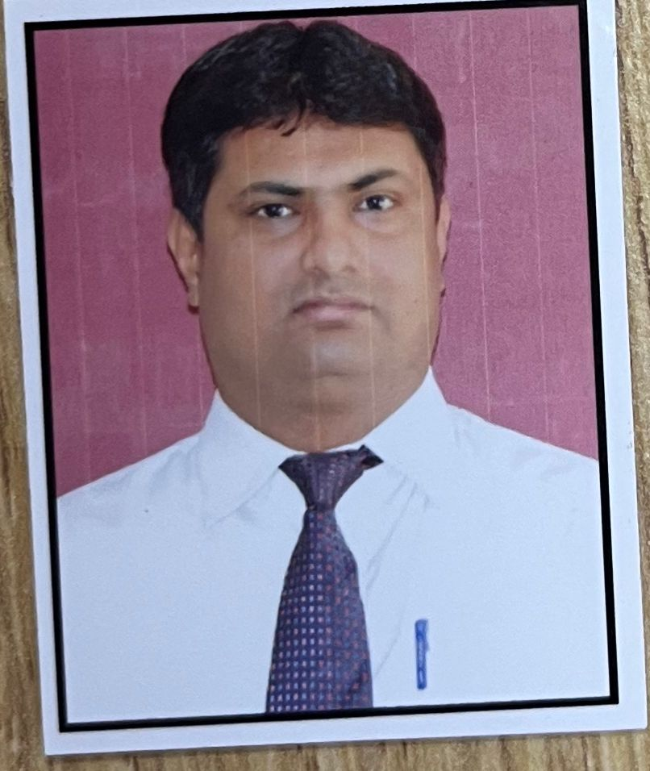
Institute Name | PDEA`s Institute of Technical Education Research and Management, Akurdi, Pune.
Designation | Assistant Professor
Department | MBA
Area of Specialization | Human Resource Management
Date of Joining the Institute | 11/04/2026
Qualifications with Class/Grade | PG  M.P.M | First Class | UG  B.Com. | First Class | Other
Total Experience in Years | Teaching | 20years | Industry
Paper Published | International | 19 | National | - | U.G.C.N.E.T.
Books Published

